


Report Release Date
27-03-2025
Type of Audit
Website/Web Application Audit
Type of Audit Report
First Audit Report
Period
From 06-3-2025 to 27-03-2025

TS E-Challan Local Portal Web Application VAPT First Audit Report

Document Control
Document Preparation
Document Title | TS E-Challan Local Portal Web Application VAPT First Audit Report
Document ID | MDS/TG/LP/WA/01
Document Version | 1.0
Prepared by | N Kumar Sai
Reviewed by | D Naveen Kumar
Approved by | G.V Varun
Released by | G.V Varun
Release date | 27/03/2025

Document Change History
Version | Date | Remarks/Reason of change
1.0 | 26/03/2025 | Draft Report

Document Distribution List
Name | Organization | Designation | Email ID
G.V Varun | Marven Data Systems | Security Analyst | gvv@mdsinc.in
Praveen Kumar | EChallan Cell TS Police | Inspector EChallan | insp-echallantrf-hyd@tspolice.gov.in

Contents
About Us 4
Introduction 5
Statement of Confidentiality 6
Engagement Scope 6
Details of the Auditing team 7
Audit Activities and Timelines 8
Audit Methodology & Criteria/Standard referred for audit 9
Tools/Software Used 10
Executive Summary 10
Assessment Overview and Recommendations 12
Vulnerability Assessment Penetration Testing Summary 12
Detailed Observations 13
LP001: Identification and Authentication failures 13
LP002: Broken Authentication & Session Management 14
LP0003: Insecure Random OTP Generation 16
LP004: Insecure Design 17
LP005: Cryptographic failures 19
LP006: Cache control vulnerability 20
LP007: Inconsistent Rate Limiting 21
LP008: Vulnerable and Outdated Components 23
LP0009: Parallel Sessions 25
Appendices 27

About Us
Marven Data Systems (A CERT-In Empaneled Information Security Organization) is found by a group of security professionals to create a comprehensive stack of products and services for an enterprise with tailor made solutions.
Our services include but not limited to IT security risk & governance consulting, IT audits, Vulnerability assessment & penetration testing, Cloud Security Assessments, IoT Security, OT Security, Red teams & specialized services, IT Infrastructure managed services, Compliance audits, Training & Skill development.
Our security product implementation capabilities range from SIEM, Network monitoring tools, SD-WAN, Endpoint Antivirus, EDR, XDR, NextGen Firewall implementation & configurations, DLP Solutions, Ransomware traps.
Marven Data Systems have come up with a comprehensive ERP for IT Asset Management, Service Management, Patch management, Remote desktop service applications, Barcode assets management, Compliance management module, End point behavior analysis & risk indicator modules by implementing Machine learning and AI to identify & detect IOCs.
Over the years of experience working with various organizations have taught us that every business workflow is different & with it changes their requirements. Today in this ever-growing technological era all business needs are robust & need more advanced & flexible technology solutions. We have adapted our core technology expertise to build cost-effective customized hardware & software solutions to cater to your business needs. We believe in taking our technology expertise to fulfill our customer’s needs in every step of the way.

Introduction
Marven Data Systems Pvt. Ltd., was contracted by Telangana Technology Services hereafter, referred to as “TGTS” to conduct a Web application vulnerability & penetration testing on Local Portal web application carrying URL: https://echallan.tspolice.gov.in/localportalT/ in order to determine possible vulnerabilities that an attacker could possibly exploit. All activities were conducted in a manner that simulated a malicious actor engaged in a targeted attack against Local Portal web application with the goals to:
- Identify possible vulnerabilities that could be exploited.
- Vulnerable coding practice.
- Weak configurations detected.
- Weak encryptions that could enable information disclosure.
- APIs configured in the Web application.
- Secure practices followed by the organization.

Each finding has been assigned a severity rating of high, medium, or low. The rating is based off of an assessment of the priority with which each finding should be viewed and the potential impact each has on the confidentiality, integrity, and availability of Local Portal web application data.
Rating | Severity Rating Definition
Critical | Exploitation of the technical or procedural vulnerability will cause catastrophic harm. Immediate damage is almost certain, with widespread and severe consequences. The threat exposure is extremely high, and the likelihood of occurrence is virtually certain. Security controls are either non-existent or wholly ineffective, allowing the vulnerability to be easily exploited, resulting in devastating impacts that could disrupt business operations or severely compromise sensitive information.
High | Exploitation of the technical or procedural vulnerability will cause substantial harm. Significant damage is likely to result. The threat exposure is high, thereby increasing the likelihood of occurrence. Security controls are not effectively implemented to reduce the severity of impact if the vulnerability were exploited.
Medium | Exploitation of the technical or procedural vulnerability will significantly impact the confidentiality, integrity, and/or availability of the system, application, or data. Exploitation of the vulnerability may cause moderate financial loss or public embarrassment. The threat exposure is moderate-to-high, thereby increasing the likelihood of occurrence. Security controls are in place to contain the severity of impact if the vulnerability were exploited, such that further political, financial, or legal damage will not occur.  - OR -  The vulnerability is such that it would otherwise be considered High Risk, but the threat exposure is so limited that the likelihood of occurrence is minimal
Low | Exploitation of the technical or procedural vulnerability will cause minimal impact to operations. The Confidentiality, Integrity and Availability (CIA) of sensitive information are not at risk of compromise. Exploitation of the vulnerability may cause slight financial loss or public embarrassment. The threat exposure is moderate-to-low. Security controls are in place to contain the severity of impact if the vulnerability were exploited, such that further political, financial, or legal damage will not occur.  - OR -  The vulnerability is such that it would otherwise be considered Medium Risk, but the threat exposure is so limited that the likelihood of occurrence is minimal.

Statement of Confidentiality
The contents of this document have been developed by Marven Data Systems. Marven Data Systems considers the contents of this document to be proprietary and business confidential information. This information is to be used only in the performance of its intended use. This document may not be released to another vendor, business partner or contractor without prior written consent from Marven Data Systems. Additionally, no portion of this document may be communicated, reproduced, copied or distributed without the prior consent of Marven Data Systems.

Engagement Scope
S. No | Asset Description | Criticality of Asset | Internal IP Address | URL | Public IP Address | Location | Hash Value (in case of applications) | Version (in case of applications) | Other details such as make and model in case of network devices or security devices
1 | Local portal | High | N/A | https://echallan.tspolice.gov.in/localportalT/ | 123.176.35.100 | Telangana | N/A | N/A | N/A

Date up to which the list has been updated: 05-03-2025.

Details of the Auditing team
S. No | Name | Designation | Email ID | Professional  Qualifications
1 | G. V. Varun | Security Analyst (L3) | gvv@mdsinc.in | CEH
2 | D. Naveen Kumar | Security Analyst (L2) | naveend@mdsinc.in | CNSP, security Operations and the Defense Analyst
3 | T Vishnuvardhan | Security Analyst (L2) | vishnut@mdsinc.in | Masters in Cyber Security
4 | N Kumar Sai | Security Analyst (L1) | kumars@mdsinc.in | Certified Penetration Testing Engineer

Audit Activities and Timelines
The URL: https://echallan.tspolice.gov.in/localportalT/ web application is assessed to find vulnerabilities on major aspects such as server configurations, Web application design & safe code practices as per OWASP guidelines.
Server configuration:
Server configuration checks include,
- Application dependable used such as database, middleware, third-party scripts are checked for zero-day vulnerabilities.
- Communication strategy set between the client & the server.
- Server-side data validations.
- Encryption standards followed for crucial data communications over the network.
- Protocols used for the call procedures.
- Database configuration, data handling & data encryption standards set.
Web application design:
Web application design checks include,
- Front end scripting.
- Confidential data exposure.
- Client-side configurations followed.
- Client-side input validations.
- OWASP standards followed on the front-end coding.
- GET & POST requests handling.
- Requests handling procedures.
Safe coding practices:
Safe coding practices checks include,
- Overall coding structure.
- Dead code available.
- Procedure handling.
- Encryption standards used for crucial data.
- Browser options configured from the client-end.
- URL & banner configurations.
- Client-side crucial data exposure.
Along with these checks, a comprehensive testing is performed by inputting various types of malicious codes on the Web application pages noting its respective responses.

Timelines: 06/03/2025-27/03/2025.

Audit Methodology & Criteria/Standard referred for audit
The testing for the https://echallan.tspolice.gov.in/localportalT/ , our team has used the below mentioned methodology:
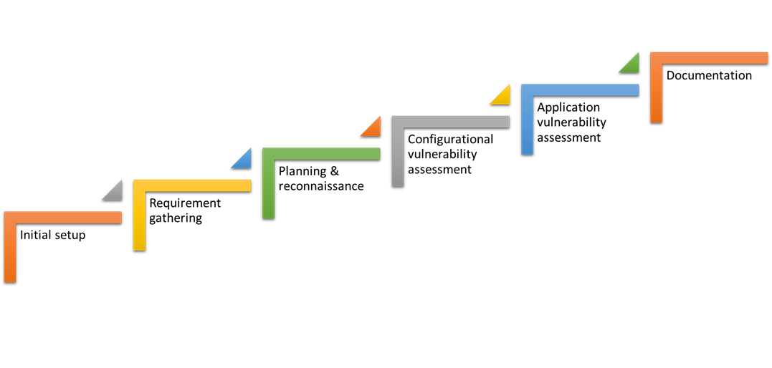
Initial setup: Initial setup involves setting up the required environment required for testing & checking the response of the test application suitable for vulnerability testing.

Requirement gathering: Requirement gathering mainly involves understanding the scope & gathering manual & automated scripts, applications needed to perform the vulnerability assessment.

Planning & reconnaissance: This stage involves gathering & understanding the Web application well & planning suitable teams, strategy & the required team to perform the vulnerability assessment.

Configurational vulnerability assessment: This stage mainly involves understanding the configuration of the Web application such as server setup, network connection, frameworks installed, database used, encryptions configured across the network, connection methodology used & perform manual & automated assessment to assess for any vulnerabilities present in the setup.

Application vulnerability assessment: At this phase the application is tested for any vulnerabilities both manually & automated. There are various aspects assessed at this phase such as client-side input validations, client-end data exposure, WAF configurations, safe coding practices, URL handling Etc.

Documentation: At this phase all the prospects regarding the assessment are gathered & documented.

The above-mentioned methodology is used to perform vulnerability assessment on the devices under the scope.

Tools/Software Used
Sr. No. | Tool | Version | Open Source/ Licensed
1 | Nmap | Version 7.95 | Open Source
2 | Burp suite | Version 2024.3.1.2 | Licensed
3 | ZAP | Version 6.1 | Open Source

Executive Summary
Vulnerability Identifier | Affected Asset i.e., IP/URL/Application Etc | Vulnerability title | CVE/CWE | No of Occurrences | Severity
LP001 | https://echallan.tspolice.gov.in/localportalT/ | Identification and Authentication Failures | A07:2021 | 1 | High
LP002 | https://echallan.tspolice.gov.in/localportalT/ | Broken Authentication & Session Management | A07:2021 | 1 | High
LP003 | https://echallan.tspolice.gov.in/localportalT/login.jsp | Insecure Random OTP generation | CWE-770 | 1 | Medium
LP004 | https://echallan.tspolice.gov.in/localportalT/login.jsp | Insecure Design | CWE-522 | 1 | Low
LP005 | https://echallan.tspolice.gov.in/localportalT/ | Cleartext transmission of sensitive data | CWE-319 | 1 | Low
LP006 | https://echallan.tspolice.gov.in/localportalT/ | Cache control vulnerability | CWE-525 | 1 | Low
LP007 | https://echallan.tspolice.gov.in/localportalT/login.jsp | Inconsistent Rate Limiting | CWE-770 | 1 | Low
LP008 | https://echallan.tspolice.gov.in/localportalT/BarcodeScan.jsp  https://echallan.tspolice.gov.in/localportalT/dayReport.jsp  https://echallan.tspolice.gov.in/localportalT/js/jquery-ui-1.10.3.custom.js | Vulnerable version of the library jquery | A06:2021 | 2 | Low
LP009 | https://echallan.tspolice.gov.in/localportalT/index.jsp | Parallel Sessions | CWE-384 | 1 | Low

Assessment Overview and Recommendations
During the internal vulnerability assessment and Penetration Testing against Local Portal, Marven Data Systems identified Ten (10) findings that threaten the confidentiality, integrity, and availability of Local Portal. The findings were categorized by severity level, with two (2) of the findings being assigned a high-risk rating, Medium one (1) medium-risk, and Low six (6) low risk. There was also Zero (0) informational finding related to enhancing security monitoring capabilities within the internal network.

The tester found that the application is vulnerable and poorly implemented, allowing the OTP to be viewed in the application before it is sent to the provided mobile number. While the OTPs are insecure random, the system still allows them to be predicted. Additionally, the application lacks proper rate limiting, making it susceptible to attacks. To improve security, use secure random methods and six-digit OTPs should be implemented.

The tester also found that due to the application’s insecure implementation, the system validates the username and password and creates a session before the OTP is entered, allowing users to access the application prematurely. As a result of this poor implementation, an unauthorized user who knows the credentials of an authorized user can manipulate the URL and gain access without the OTP. To fix this, sessions should be created only after the OTP is validated.

The tester finally found that the application is using vulnerable libraries which can compromise applications CIA triad if an attacker can leverage the vulnerable libraries.

Vulnerability Assessment Penetration Testing Summary
Marven Data Systems began all testing activities from the perspective of What kind of damage could an attacker cause if they had access to credentials. Local Portal provided the tester with web application details and Login Credentials.

Detailed Observations

LP001: Identification and Authentication failures
Affected Asset i.e. IP/URL/Application etc. | https://echallan.tspolice.gov.in/localportalT/
Observation/ Vulnerability title | Identification and Authentication failures.
CVE/CWE | A07:2021
Severity | High
Reference | https://owasp.org/Top10/A07_2021-Identification_and_Authentication_Failures/
New or Repeat observation | New

Detailed Observations/Vulnerable point:
we observed that when logging into the application using the username and password, the system generates an OTP and sends it to the registered mobile number. However, we noticed that the OTP is exposed in the response, which could potentially lead to unauthorized access. This vulnerability can be exploited by an attacker who intercepts or inspects the response, potentially compromising user accounts.

We also observed that application is also revealing the mobile number of the login user, which is not recommended, an attacker can take a leverage it to some other attacks like social engineering and phishing attacks.

Reference to evidences/Proof of Concept:
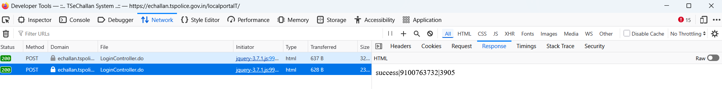

Recommendation:
- Never include OTPs in API responses or URLs. Deliver them through secure channels like SMS or email.
- Do not log sensitive information, including OTPs.
- Limit the number of OTP requests to prevent brute-force attacks on OTP generation.
- Configure the application not to send mobile number in response even if it is with valid credentials.

LP002: Broken Authentication & Session Management
Affected Asset i.e. IP/URL/Application etc. | https://echallan.tspolice.gov.in/localportalT/
Observation/ Vulnerability title | Broken Authentication & Session Management
CVE/CWE | A07: 2021
Severity | High
Reference | https://owasp.org/Top10/A07_2021-Identification_and_Authentication_Failures/
New or Repeat observation | New

Detailed Observations/Vulnerable point:
We logged into the web application using my username and password. Instead of entering the two-factor authentication (2FA) such as OTP, I modified the URL to access a different endpoint from https://echallan.tspolice.gov.in/localportalT/login.jsp to https://echallan.tspolice.gov.in/localportalT/index.jsp After doing so, I was able to bypass the 2FA requirement entirely. This allowed me to access the website directly without completing the authentication process. This behaviour indicates a potential security vulnerability in the 2FA implementation
The application does not send a request to the server for OTP validation, which allows users to bypass the authentication process. Unauthorized users can gain access without proper server-side verification.

Reference to evidences/Proof of Concept:
Original Request
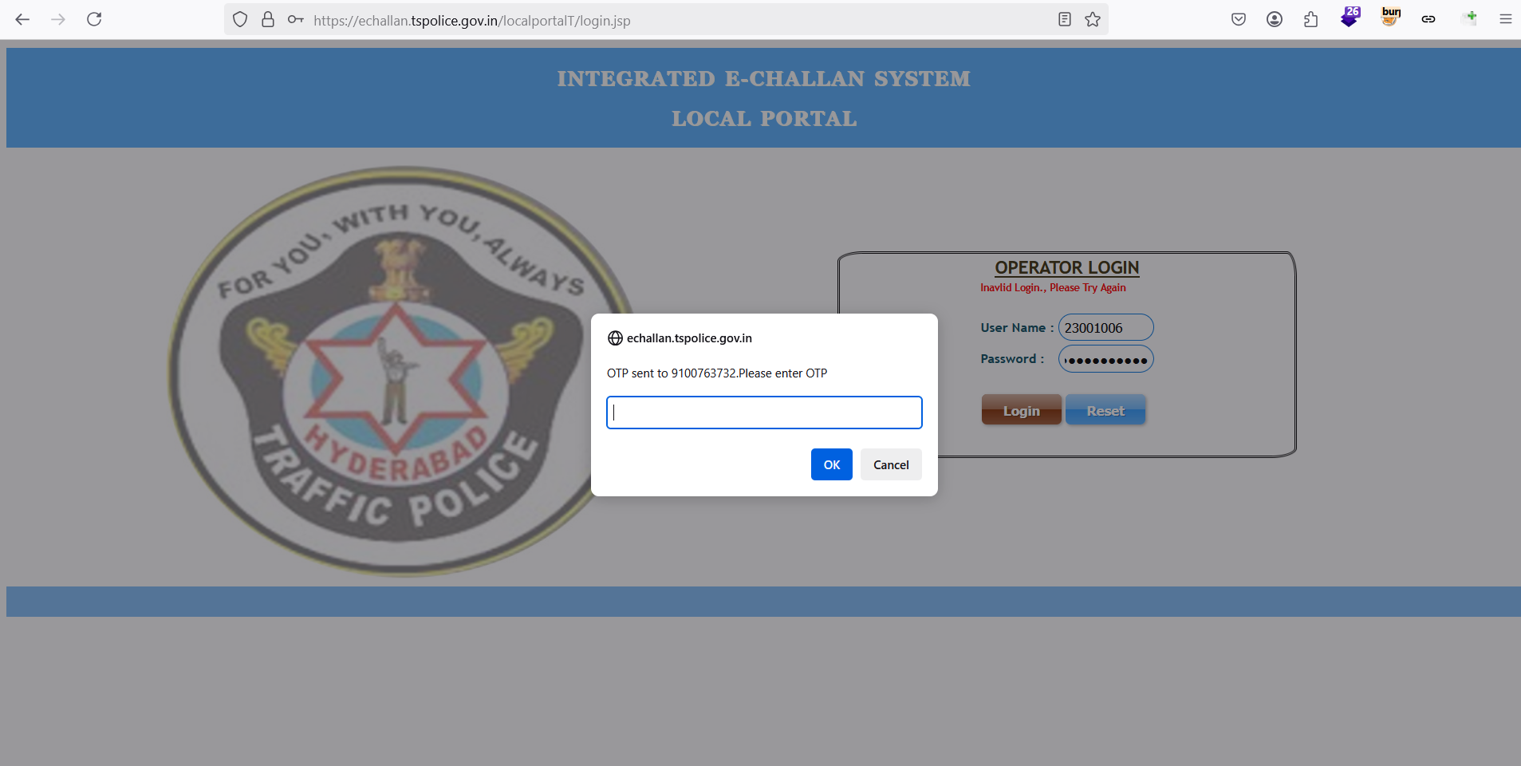

Modified Request
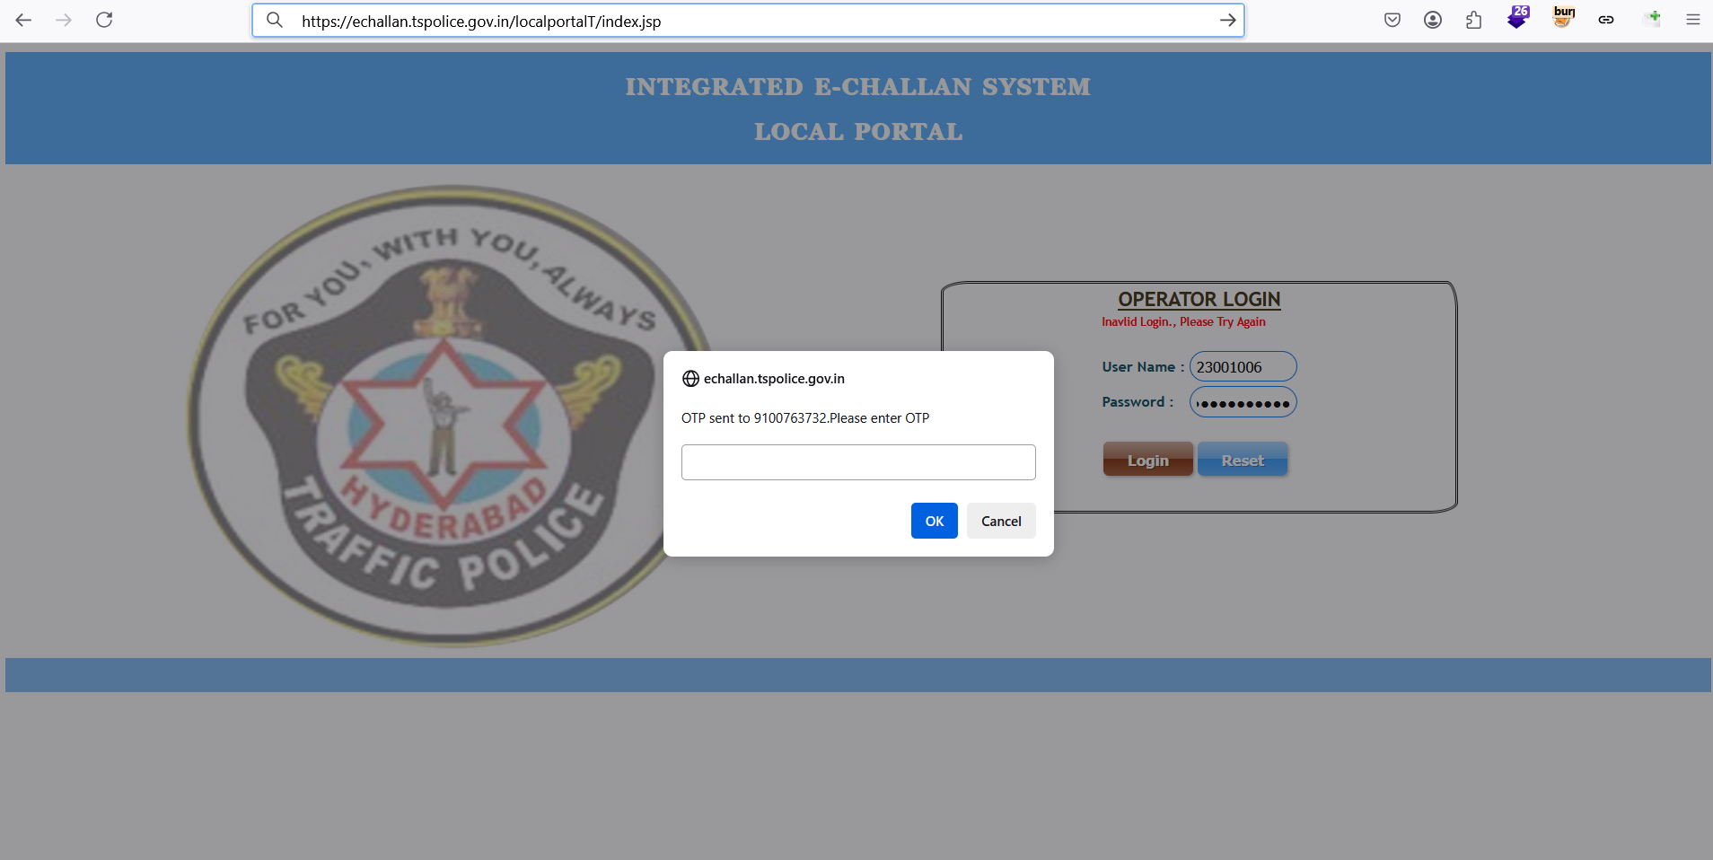

Response
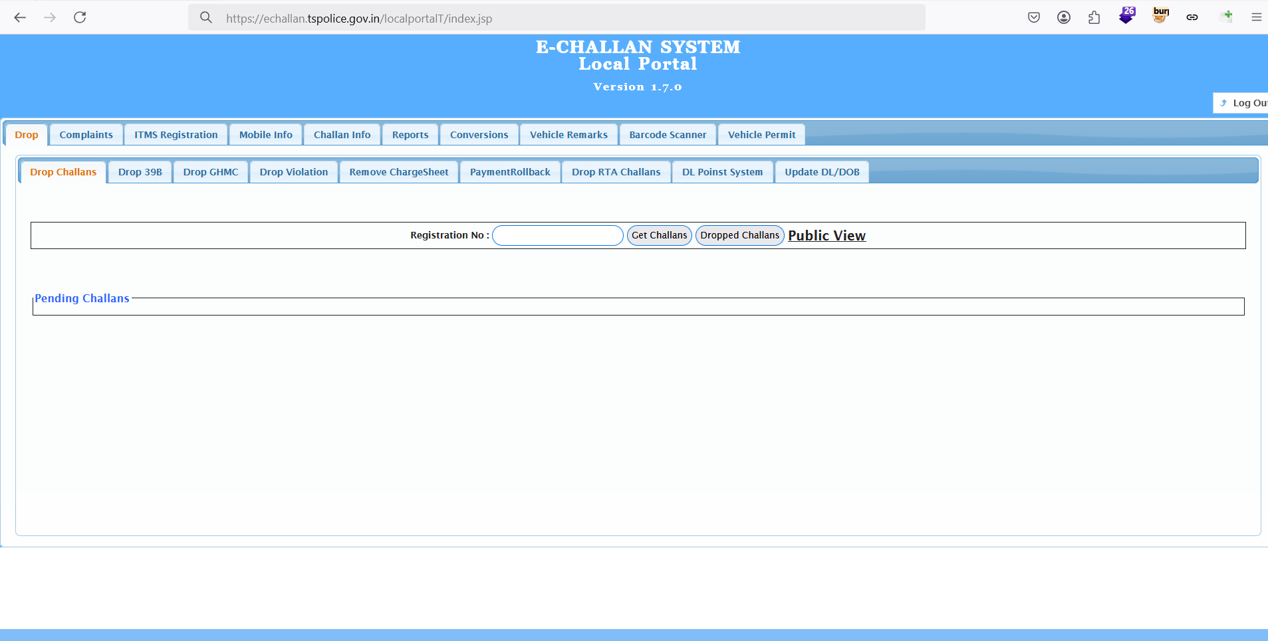

Recommendation:
- The application should not create a session before validating the OTP/ MFA.
- Application should encode sensitive information in application layer
- Use lockout mechanisms if a session is inactive after some time
- Create a blacklisted passwords list in the database to prevent using weak passwords like company@1234, company@year and username@1234 etc.
- The application must send a request to the server for OTP validation before granting access. This ensures that the OTP is properly verified and prevents unauthorized access.
- Implement robust, server-side authentication mechanisms to ensure all credentials and OTPs are validated securely.

LP0003: Insecure Random OTP Generation
Affected Asset i.e. IP/URL/Application etc. | https://echallan.tspolice.gov.in/localportalT/
Observation/ Vulnerability title | Insecure Random OTP Generation
CVE/CWE | CWE-770
Severity | Medium
Reference | https://cwe.mitre.org/data/definitions/770.html
New or Repeat observation | New

Detailed Observations/Vulnerable point:
When we conducted a null payload attack on the application, we discovered that the system is vulnerable to rate limiting and is also sending the same OTPs repeatedly.

Reference to evidences/Proof of Concept:
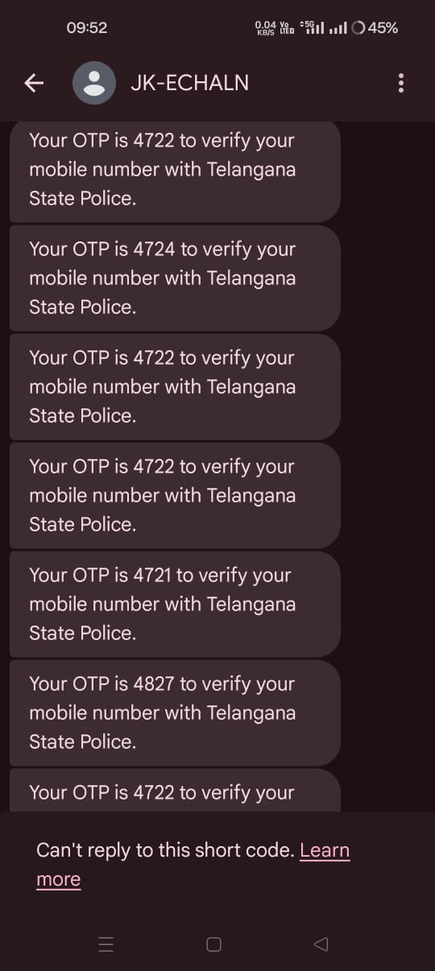

Recommendation:
- Ensure OTPs are generated using secure, cryptographically random algorithms (e.g., time-based or HMAC-based OTPs) to prevent predictability and repetition.
- Implement the six-digit OTP and generate random OTPs to enhance security.
- Include unique elements (e.g., session identifiers, timestamps) in OTP generation to make each OTP distinct, even for identical payloads.
- Ensure OTPs expire after a short time window and cannot be reused for subsequent requests.

LP004: Insecure Design
Affected Asset i.e. IP/URL/Application etc. | https://echallan.tspolice.gov.in/localportalT/login.jsp
Observation/ Vulnerability title | Insecure Design
CVE/CWE | CWE- 522
Severity | Low
Reference | https://cwe.mitre.org/data/definitions/522.html
New or Repeat observation | New

Detailed Observations/Vulnerable point:
During the login process, if a user enters incorrect OTP the application is revealing mobile number of users, which can be leveraged by attacker to conduct further attacks.

Reference to evidences/Proof of Concept:
Request
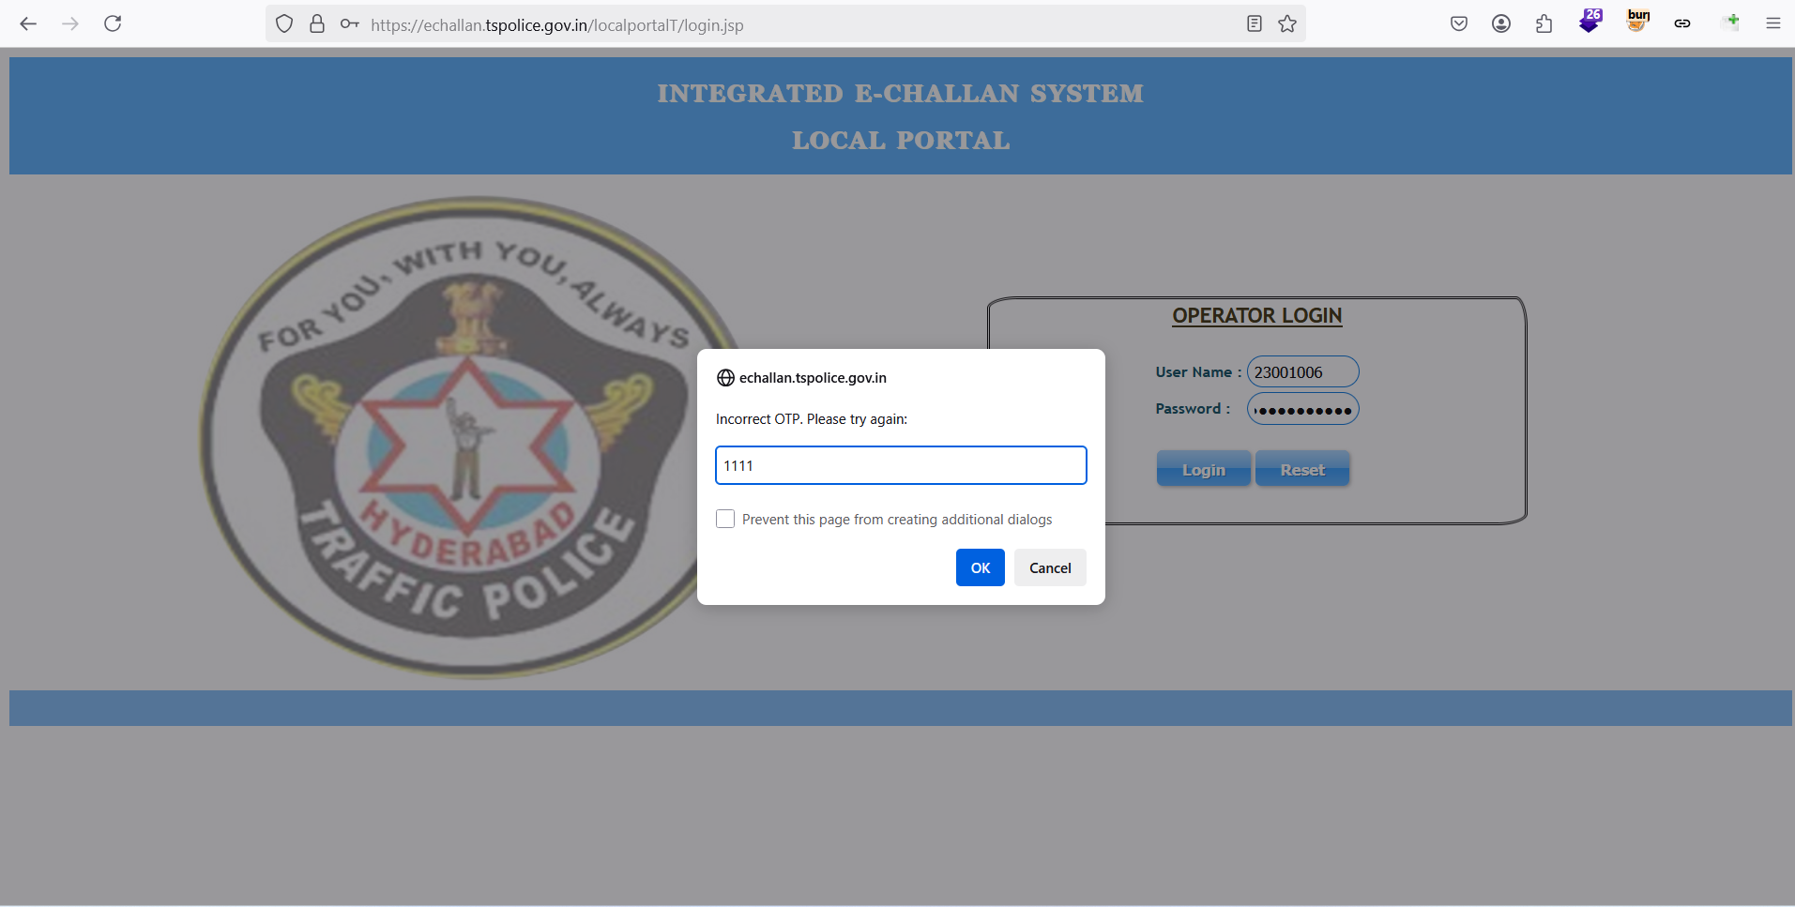

Request sent to the server
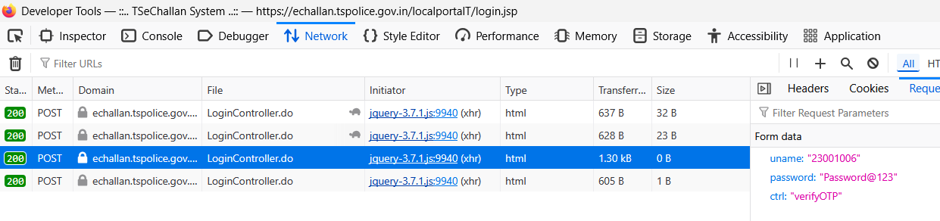

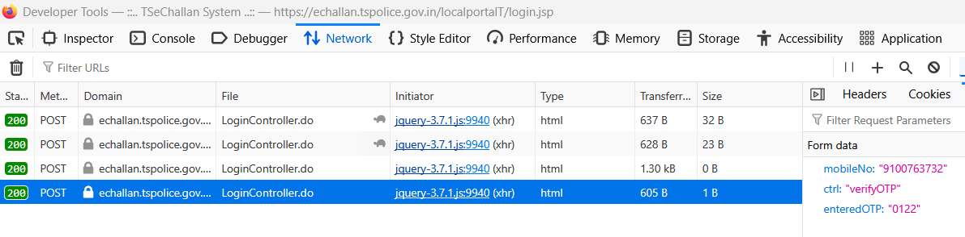

Recommendation:
- Ensure that failed login attempts or incorrect OTP entries do not leak any additional information (e.g., mobile numbers). Implement error handling that does not provide clues or sensitive data about the user to prevent information leakage.
- Ensure access controls are in place to ensure that only authorized users and systems can access sensitive information like mobile numbers. The mobile number should only be revealed to the legitimate user and not exposed to unauthorized requests.

LP005: Cryptographic failures
Affected Asset i.e. IP/URL/Application etc. | https://echallan.tspolice.gov.in/localportalT/
Observation/ Vulnerability title | Cryptographic Failures
CVE/CWE | CWE-319
Severity | Low
Reference | https://cwe.mitre.org/data/definitions/319.html
New or Repeat observation | New

Detailed Observations/Vulnerable point:
The application is sending the data such as Credentials in cleartext. The attacker can read the data from the web browser if he compromises the host machine to perform various attacks or compromise the application credentials.

Reference to evidences/Proof of Concept:
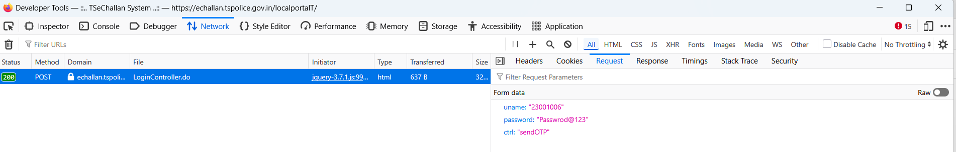

Recommendation:
- Implement client-side encryption for password fields before data submission. This ensures that even if an attacker gains access to the transmission data, they cannot easily decrypt the passwords without the encryption key.
- Store passwords using strong, adaptive hashing algorithms like bcrypt, Argon2, or PBKDF2 with a salt.
- Prevent browsers from auto filling passwords.

LP006: Cache control vulnerability
Affected Asset i.e. IP/URL/Application etc. | https://echallan.tspolice.gov.in/localportalT/
Observation/ Vulnerability title | Cache control vulnerability
CVE/CWE | CWE -525
Severity | Low
Reference | https://cwe.mitre.org/data/definitions/525.html
New or Repeat observation | New

Detailed Observations/Vulnerable point:
The vulnerability arises from improper configuration of cache control headers in server responses. Specifically, the Expires header is set to an outdated date, Thu, 01 Jan 1970 00:00:00 GMT, which is a known epoch date. This configuration can result in sensitive information being cached longer than intended or inappropriately cached by intermediary systems (like proxies) or client browsers.

Reference to evidences/Proof of Concept:
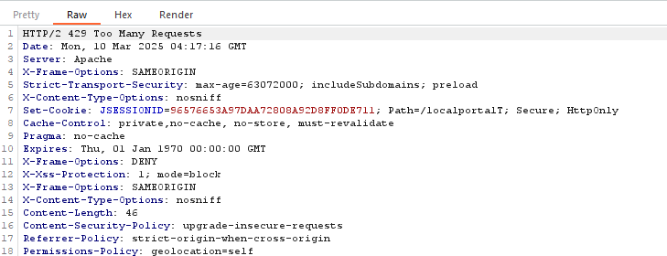

Recommendation:
- Use Cache-Control headers to explicitly control how, and for how long, content should be cached.
- Set the Expires header to a reasonable future date or use it in conjunction with Cache-Control for specific caching policies.
- For pages that contain sensitive information (e.g., user data, financial transactions), ensure that cache control headers prevent caching.

LP007: Inconsistent Rate Limiting
Affected Asset i.e. IP/URL/Application etc. | https://echallan.tspolice.gov.in/localportalT/
Observation/ Vulnerability title | Inconsistent Rate Limiting
CVE/CWE | CWE-770
Severity | Low
Reference | https://cwe.mitre.org/data/definitions/770.html
New or Repeat observation | New

Detailed Observations/Vulnerable point:
Testing the web application's login security involved using Proxy tool, utilized to automate the OTP request process during both account registration and login. By generating 50 automated requests, I was able to receive 50 OTPs. This indicates that the OTP generation mechanism lacks proper rate-limiting controls, potentially making it vulnerable to abuse, such as brute force attacks or denial-of-service (DoS) attacks.

Reference to evidences/Proof of Concept:
Request
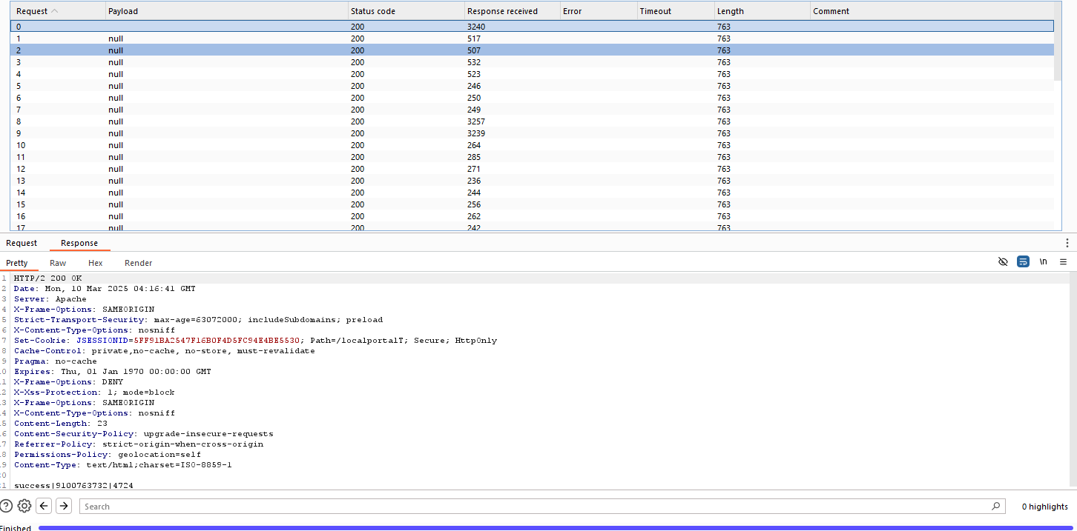

Response


Recommendation:
- Implement OTP generation to prevent OTP flooding.
- Ensure that rate limiting is consistently enforced across all request ranges to prevent brute force attacks.
- The rate limit should remain effective regardless of the request number.
- Implement lockout mechanisms both on the account and IP address combined with user agent.

LP008: Vulnerable and Outdated Components
Affected Asset i.e. IP/URL/Application etc. | Local Portal Web Application
Observation/ Vulnerability title | Vulnerable and Outdated Components
CVE/CWE | A06:2021
Severity | Low
Reference | https://owasp.org/Top10/A06_2021-Vulnerable_and_Outdated_Components/
New or Repeat observation | New

Case1: Vulnerable jQuery
Detailed Observations/Vulnerable point:
jQuery v1.4.2 and jQuery v1.6 both contain multiple known vulnerabilities that can expose web applications to security risks. jQuery v1.4.2 is particularly vulnerable to Cross-Site Scripting (XSS) attacks, where malicious scripts can be injected and executed, compromising the security of users. Similarly, jQuery v1.6 also has XSS vulnerabilities and issues related to script injection and improper handling of untrusted data. Both versions lack adequate protection against DOM-based vulnerabilities, which could allow attackers to manipulate the DOM and access sensitive user data.

Reference to evidences/Proof of Concept:
Affected Asset i.e. IP/URL/Application etc: https://echallan.tspolice.gov.in/localportalT/BarcodeScan.jsp
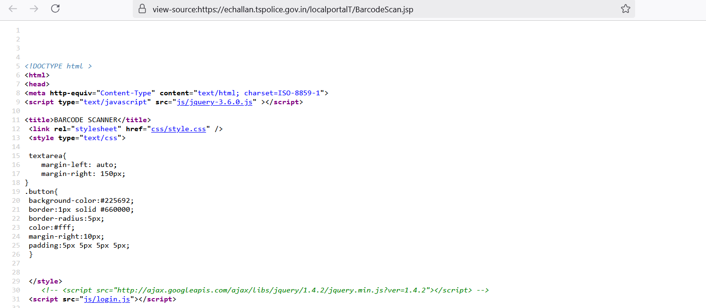

Affected Asset i.e. IP/URL/Application etc: https://echallan.tspolice.gov.in/localportalT/dayReport.jsp
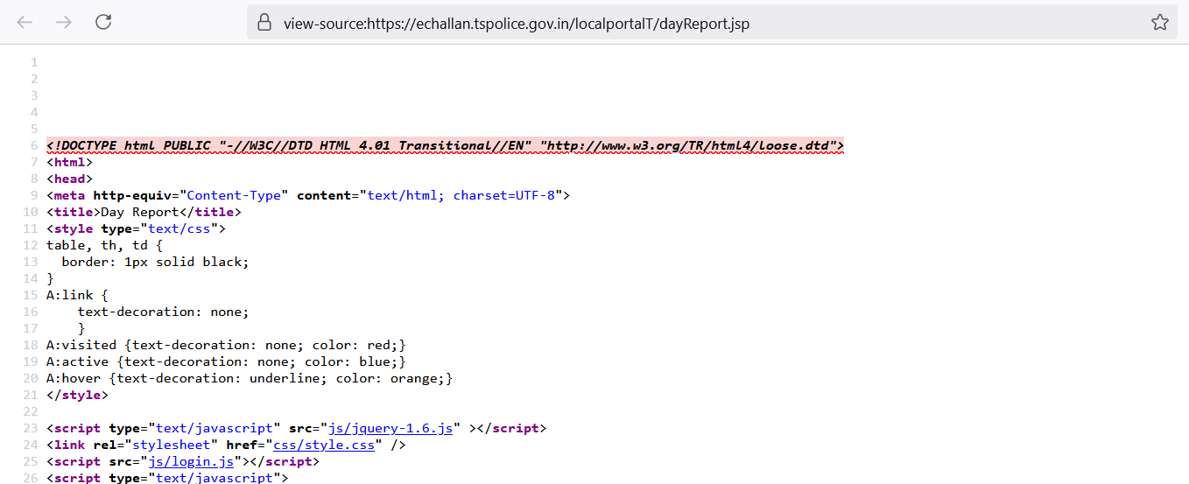

Case2: Vulnerable jQuery UI v1.10.3
Detailed Observations/Vulnerable point:
jQuery UI v1.10.3 contains several vulnerabilities, primarily related to Cross-Site Scripting (XSS) attacks, where malicious users can inject harmful scripts into web pages. This version also has issues with event handling that could allow attackers to manipulate the DOM and potentially perform unauthorized actions on behalf of users. Additionally, improper sanitization of user input increases the risk of DOM-based attacks, exposing sensitive data. Upgrading to a more recent version of jQuery UI is essential to address these security flaws and benefit from important security patches.

Reference to evidences/Proof of Concept:
Affected Asset i.e. IP/URL/Application etc: https://echallan.tspolice.gov.in/localportalT/js/jquery-ui-1.10.3.custom.js
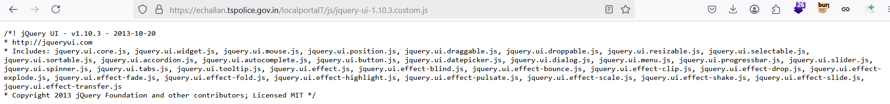

Recommendation:
- Upgrade to the latest stable version

LP0009: Parallel Sessions
Affected Asset i.e. IP/URL/Application etc. | https://echallan.tspolice.gov.in/localportalT/ index.jsp
Observation/ Vulnerability title | Parallel Sessions
CVE/CWE | CWE-384
Severity | Low
Reference | https://cwe.mitre.org/data/definitions/384.html
New or Repeat observation | New

Detailed Observations/Vulnerable point:
Parallel session vulnerabilities arise when a user is able to maintain and operate multiple active sessions simultaneously, usually without proper session management controls. Insecure handling of parallel sessions can lead to several security risks, including session fixation, session hijacking, or improper application behaviour. Attackers might exploit this vulnerability by initiating multiple sessions in parallel for a single user and manipulate or hijack one of them to perform malicious actions.

Reference to evidences/Proof of Concept:
Session 1:
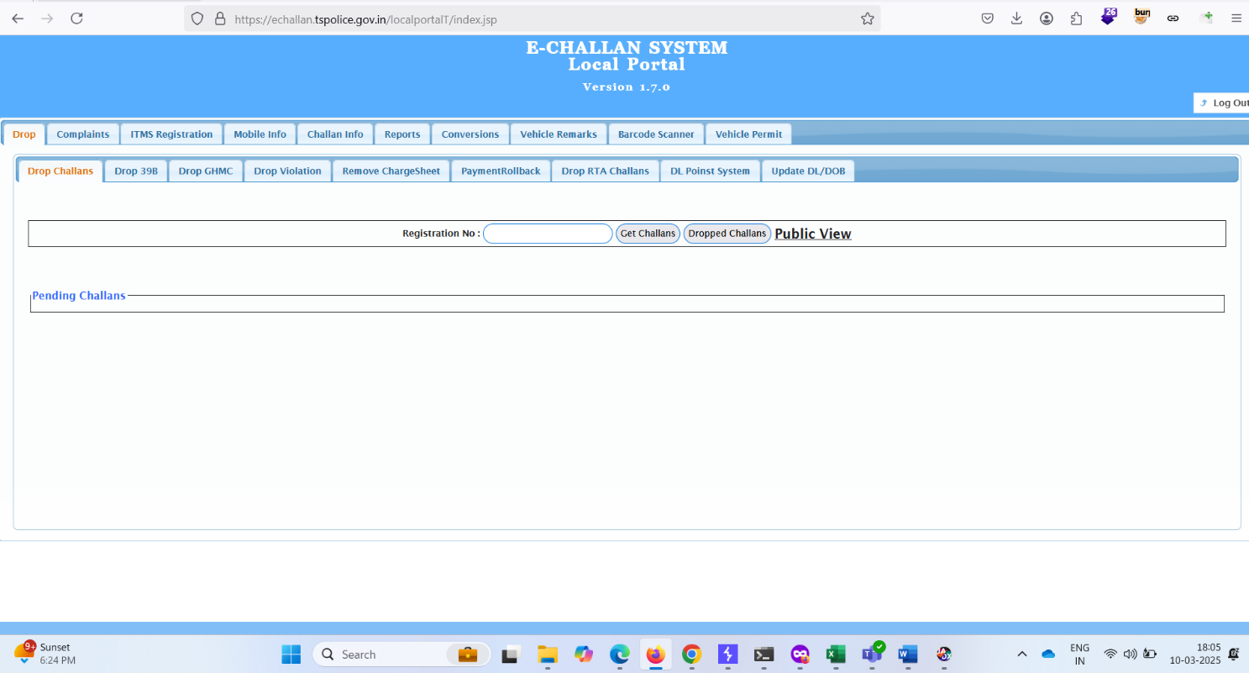

Session 2:
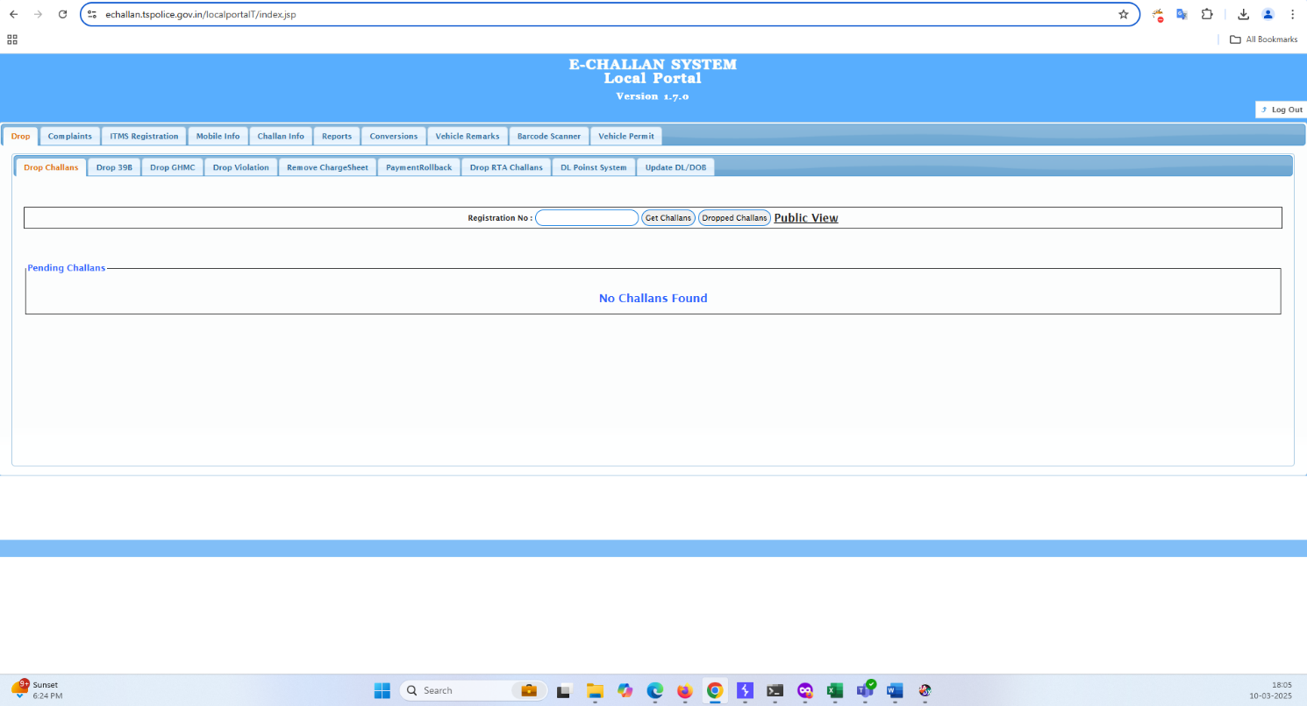

Recommendation:
- Restrict each user to a single active session at any given time. When the user logs in from a new location or device, terminate the previous session automatically.
- If the session is accessed from a different IP or device, force re-authentication or invalidate the session.
- Implement CSRF Tokens to ensure that actions initiated in one session cannot be abused across multiple sessions.

Appendices
Information gathering and reconnaissance
Ping
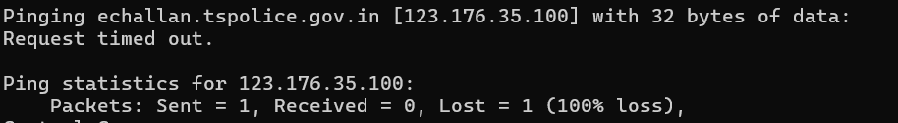

Traceroute
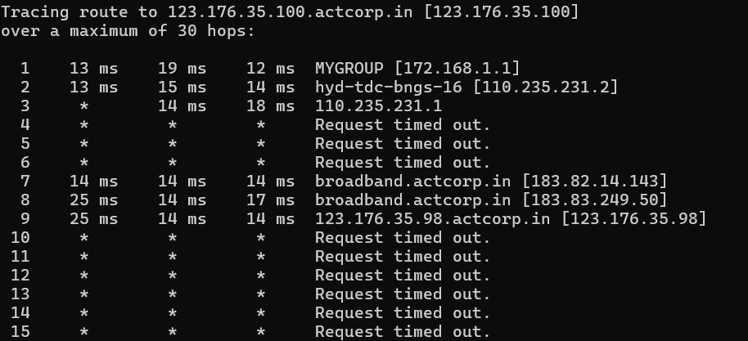

Nmap
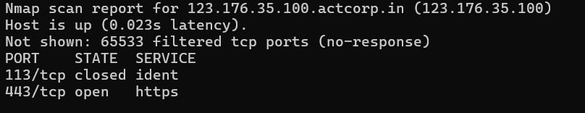

Web Application firewall detection
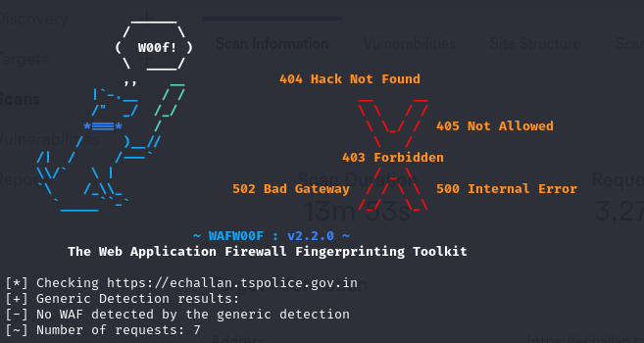

Load balancer detection
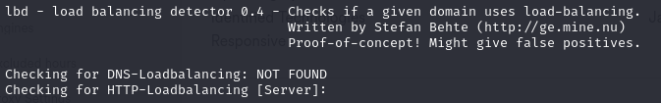

Technology stack identification
Category | Technology | Version
Security | HSTS | N/A
Security | reCAPTCHA | N/A
Font scripts | Google Font API | N/A
Miscellaneous | HTTP/2 | N/A
Miscellaneous | Popper | N/A
Web servers | Apache HTTP Server | N/A
JavaScript graphics | Highcharts | 4.0.3
Programming languages | Java | N/A
Programming languages | PHP | N/A
CDN | jsDelivr | N/A
CDN | cdnjs | N/A
CDN | jQuery CDN | N/A
CDN | Cloudflare | N/A
Maps | Google Maps | N/A
JavaScript libraries | jQuery | 3.6.0
JavaScript libraries | Moment.js | 2.18.1
JavaScript libraries | DataTables | 1.11.5
JavaScript libraries | JSZip | 3.1.3
JavaScript libraries | core-js | 2.6.5
JavaScript libraries | SweetAlert | N/A
JavaScript libraries | crypto-js | 4.0.0
JavaScript libraries | jQuery UI | 1.10.3
JavaScript libraries | Polyfill | 3
JavaScript libraries | lit-element | 4.1.1
JavaScript libraries | lit-html | 3.2.1
UI frameworks | Bootstrap | 4

